**Word Cloud**

**Word Frequency**

**Pre-processed Reviews negative reviews**

**LDA (Latent Dirichlet Allocation)**

**NMF (Non-negative Matrix Factorization**

**)**

**Topic Modelling only on Nouns**

**Topic Modelling**

**Apple wordCloud**

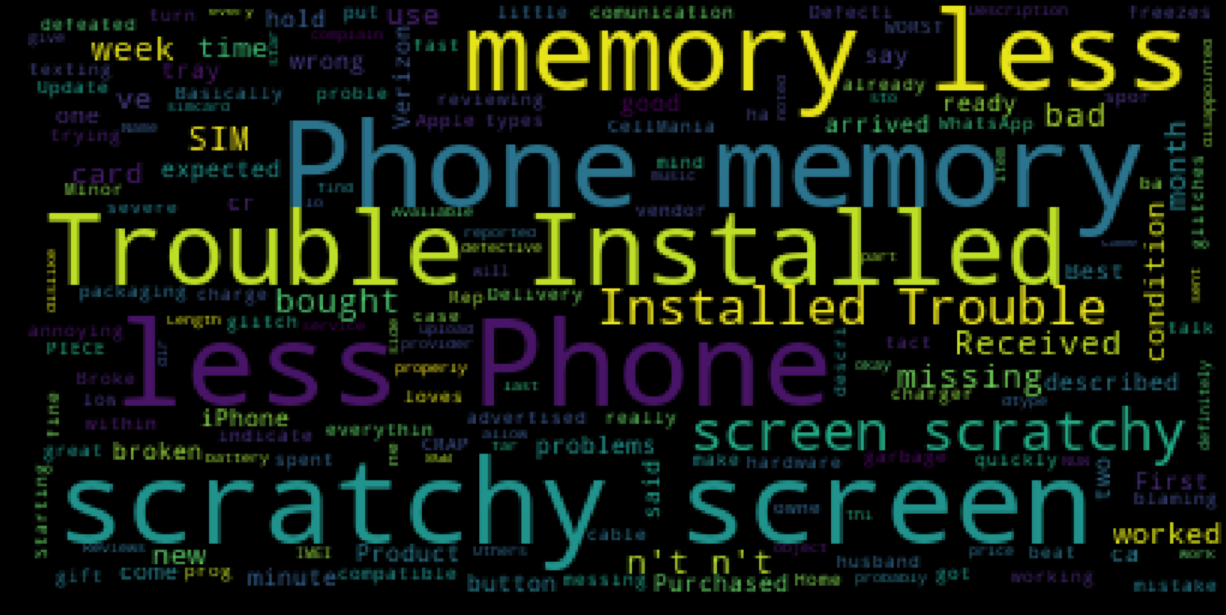

**Samsung WordCloud**

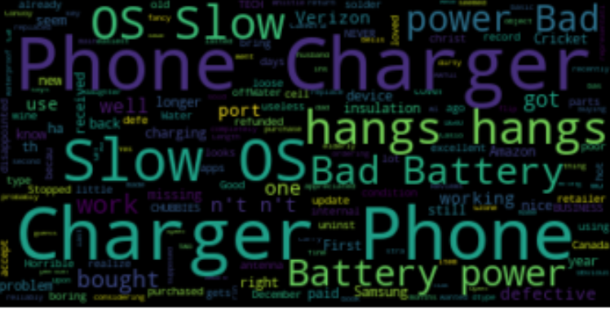

**1) Tokenization**

**2) Stop word removal**

**3) Deleting reviews < 3 words**

**4) Lemmatization**

**Apple**

**Text Pre-processing /Cleaning**

**Neutral**

**VADER (Sentimental Polarity)**

**Negative reviews**

**Positive reviews**

**Samsung**

**Reviews**

**Amazon Electronic Gadgets dataset**